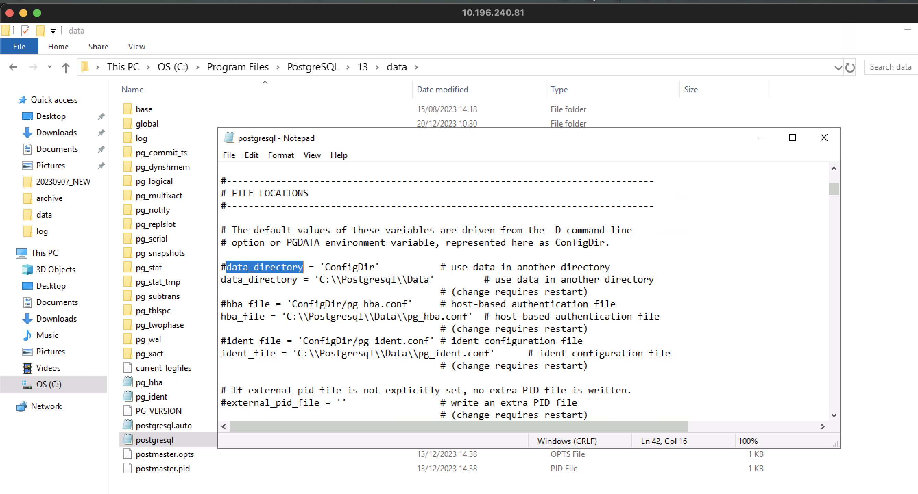

0. backup the database

pg_dump -U postgres db_ods > C:\archive\db_archive\db_ods_backup_yyyyMMdd_mmss.dump

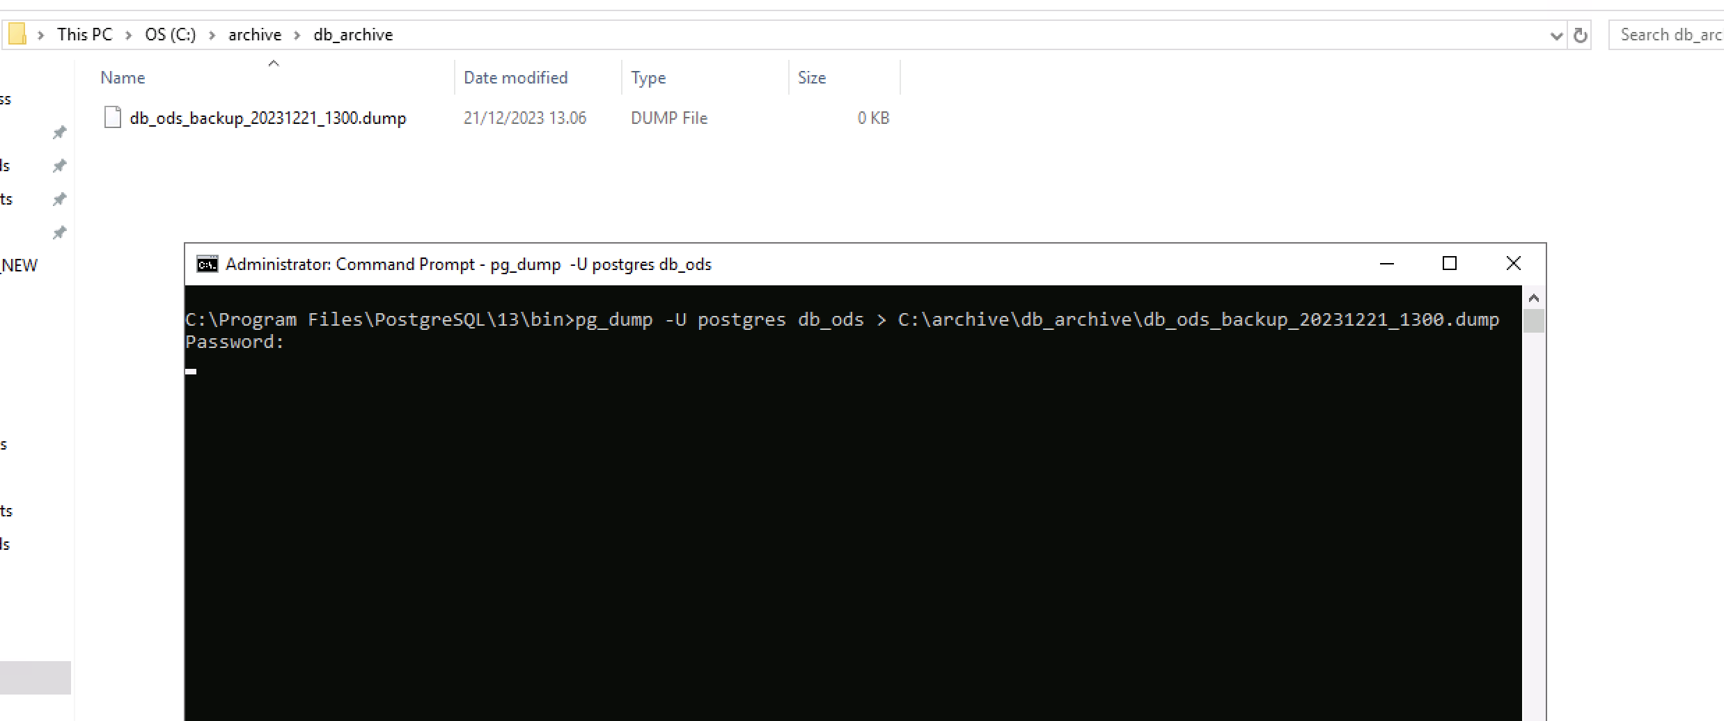

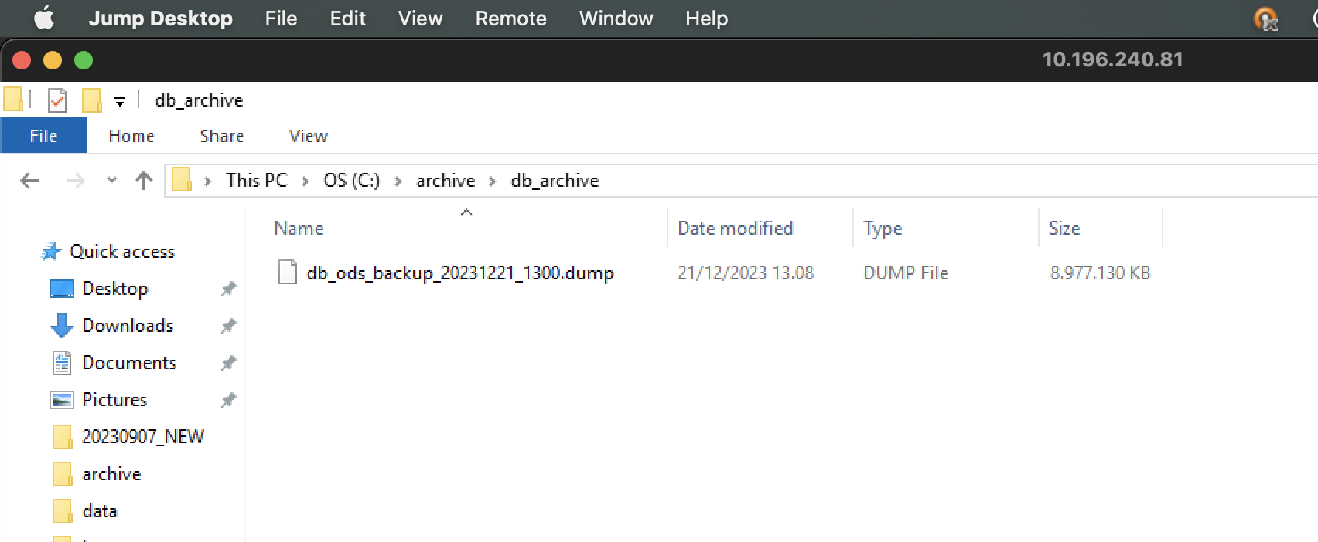

1. check current location data_directory in postgres

show data_directory;

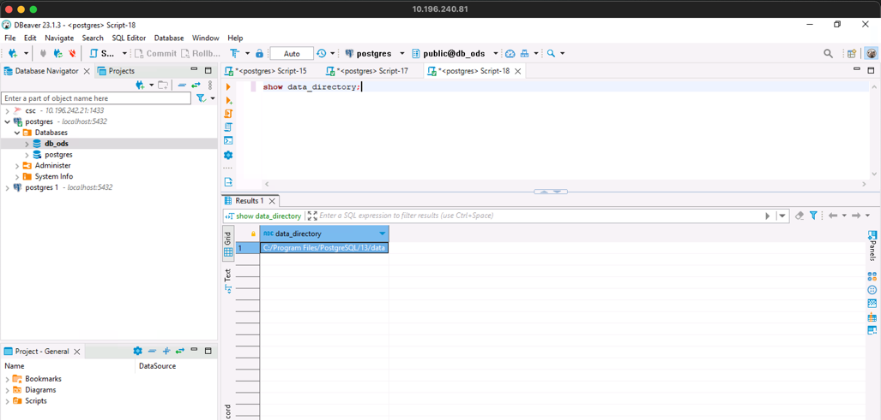

2. stop postgresql services

pg_ctl.exe -D "C:\Program Files\PostgreSQL\13\data" stop

3. copy old data directory to new data directory (make sure permission same with old data directory)

example:

old data directory: C:/Program Files/Postgresql/13/data

new data directory: D:/Postgresql/13/Data

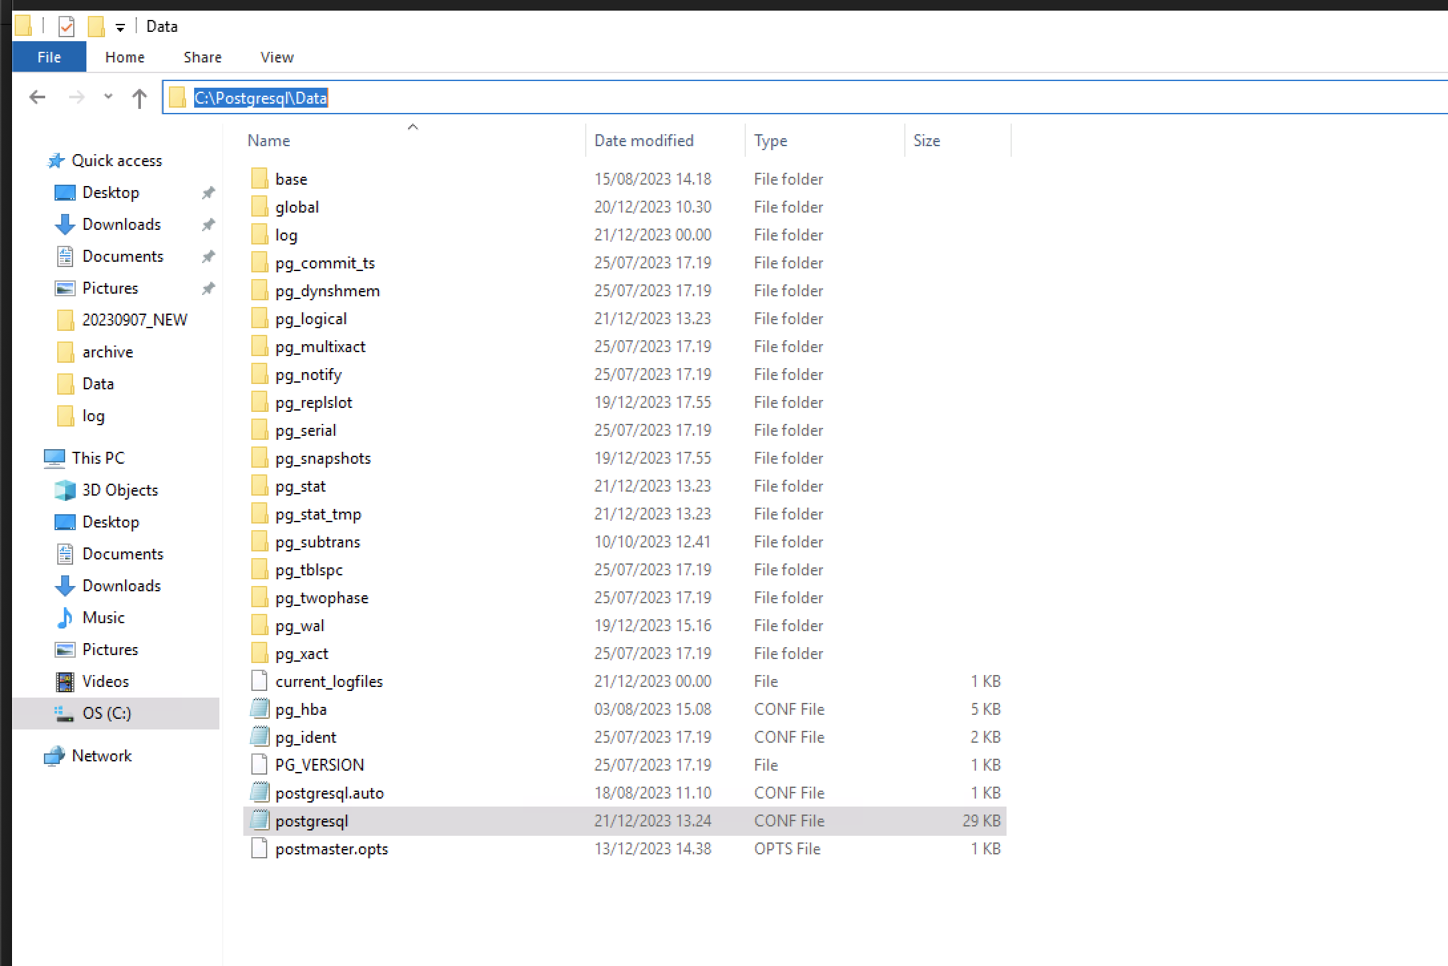

4. change ImagePath in registry editor HKEY_LOCAL_MACHINE\SYSTEM\CurrentControlSet\Services\Postgresql

Old

"C:\Program Files\PostgreSQL\13\bin\pg_ctl.exe" runservice -N "postgresql-x64-13" -D "C:\Program Files\PostgreSQL\13\data" -w

New

"C:\Program Files\PostgreSQL\13\bin\pg_ctl.exe" runservice -N "postgresql-x64-13" -D "'C:\Postgresql\Data" -w

5. change postgressql.conf & save

#data_directory = 'ConfigDir' # use data in another directory

data_directory = 'C:\\Postgresql\\Data' # use data in another directory

# (change requires restart)

#hba_file = 'ConfigDir/pg_hba.conf' # host-based authentication file

hba_file = 'C:\\Postgresql\\Data\\pg_hba.conf' # host-based authentication file

# (change requires restart)

#ident_file = 'ConfigDir/pg_ident.conf' # ident configuration file

ident_file = 'C:\\Postgresql\\Data\\pg_ident.conf' # ident configuration file

# (change requires restart)

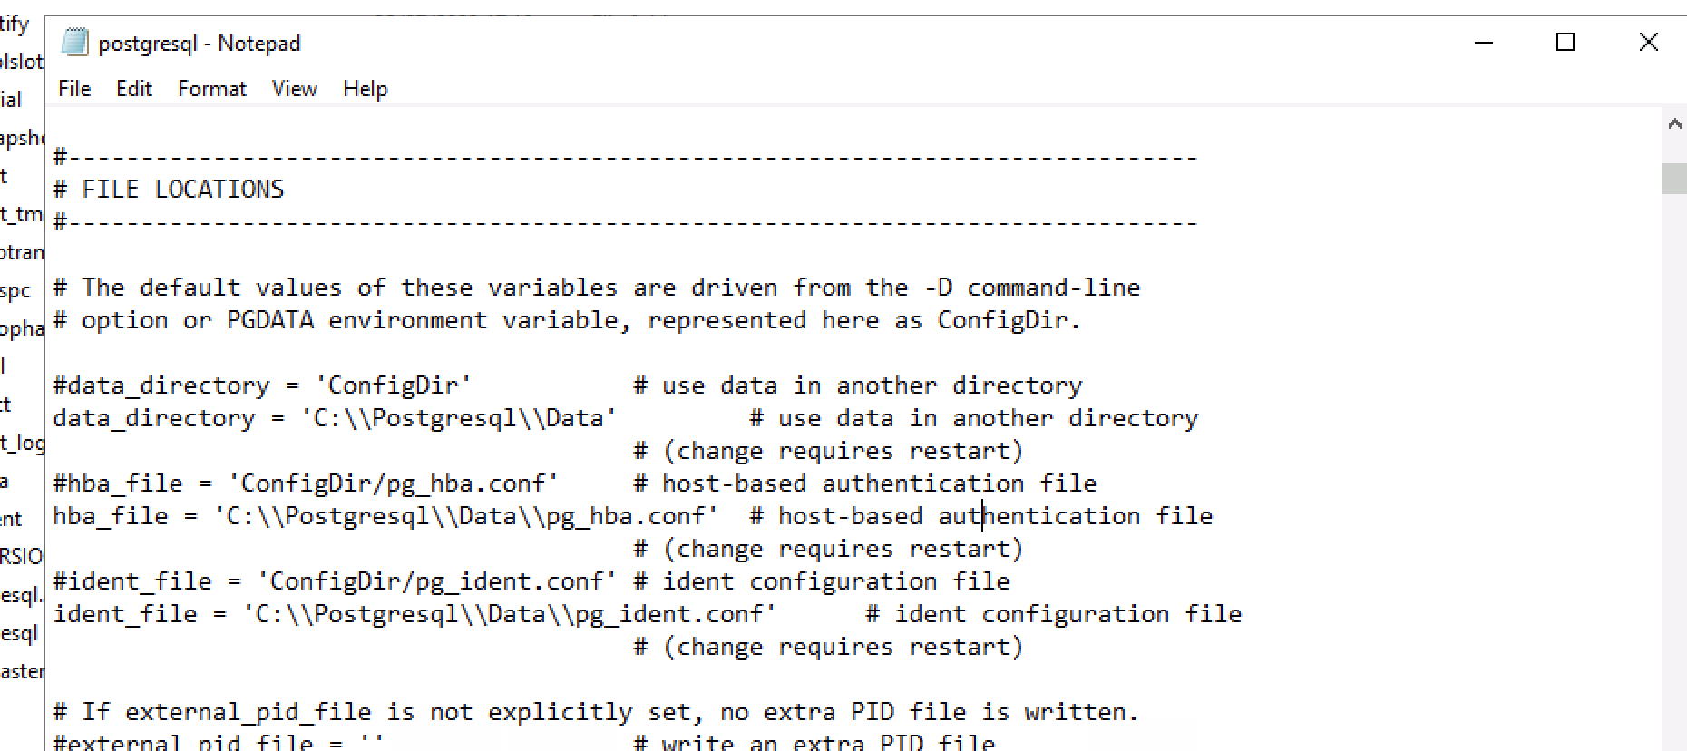

5. start the services with new data directory

pg_ctl.exe -D "C:\Postgresql\Data" start

6. make sure the changes applied, check current data directory:

show data_directory;